**REPORT: RESEARCH**

1. **Diễn đàn toán học**
2. ***Info:***

* **Link:** <http://diendantoanhoc.net/>
* **Type:** article, forum
* **Topic:** mathematics
* **Posts:** 463664
* **Member:** 78352
* **Rank in Vietnam:** 2605
* **Total Sites Linking In:** 179
* **Established:** 16/01/2014
* **Belong to:**Vietnam Mathematics Forum



1. ***Description:***

Diễn đàn toán học (Vietnam Mathematics Forum) is a voluntary organization of young people in Vietnam who are studying and working in Vietnam and many countries around the world, was established to build an online yard of Mathematics for people who love math, teach math and study math. Diễn đàn toán học was officially put into operation on 16.01.2004, the first forum of the Vietnam Mathematics.

Diễn đàn toán học is an asset of the community and not influenced by any individual or organization. It was born from the community, to serve the community and well maintained by the community.

The operation of Diễn đàn toán học is based on two main parts: Homepage introduce news and articles, and forum where members meet and discuss all issues.

Math Forum is being managed and maintained (both human and power costs) by the Board of Trustees, is a group of scientists, teachers, researchers and students...

1. ***Advantages and disadvantages:***

* *Advantages*:
* Using LaTeX to write formulas.
* Organizing math contest.
* Having topics for each level (secondary, high school, university).
* Having "tags" to search easily.
* *Disadvantages*:
* Can not login by Facebook or Gmail…
* Everything is posted (question, discussion, blog).

1. **Pitago.vn**
2. ***Info:***

* **Link:** <http://pitago.vn/>
* **Type:** online learning, online test, QA system
* **Topic:** mathematics
* **Rank in Vietnam:**37 600
* **Total Sites Linking In:** 16
* **Belong to:**Mạng Tri ThứcViệt Name company– Knetwork

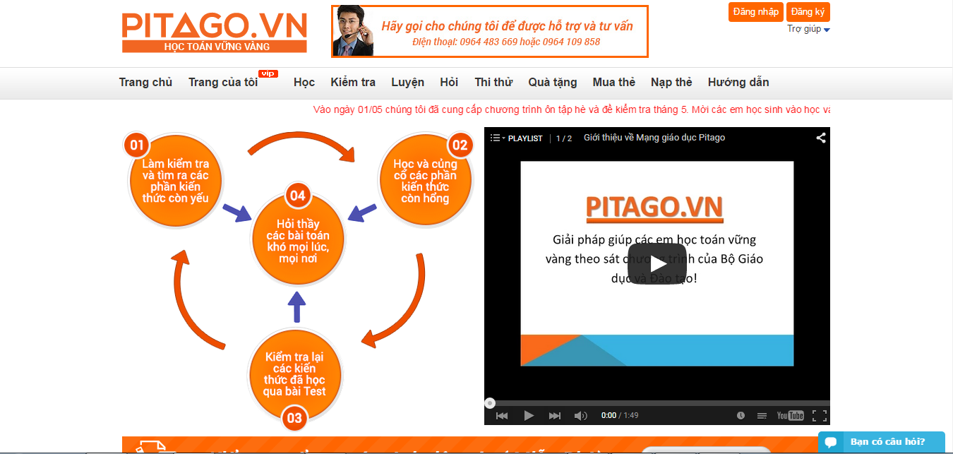

1. ***Description:***

Pitago publishes math solution to help study math steady that follow the curriculum. The first education network of Vietnam provides math tools. Built and contributed by leading education experts in the field of mathematicsCurriculum.

1. ***Advantages and disadvantages:***

* *Advantages*:
* Tests weekly, monthly follow the program on class.
* Teachers evaluate guide and share knowledge.
* User practice from basic knowledge to advance knowledge.
* User asks expert when they have problem.
* Using LaTeX to write formulas.
* Another user can comment.
* *Disadvantages*:
* Limiting level to study (Class 3 to 9).
* Must pay to see the full solution.

1. **Online Math**
2. ***Info:***

* **Link:**<http://olm.vn/>
* **Type:** online test, QA system
* **Topic:** mathematics
* **Rank in Vietnam:** 2 793
* **Total Sites Linking In:** 15
* **Belong to:** Computational Science Center - Hanoi National University of Education - JSC Science and Technology Education

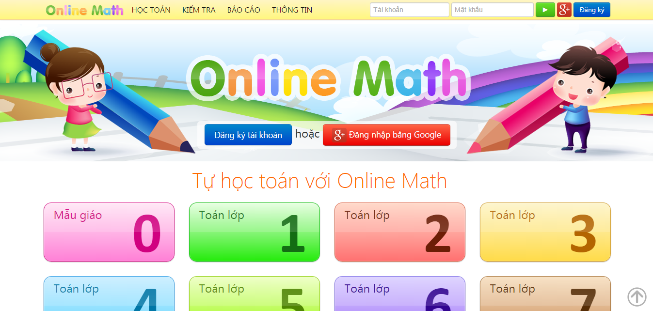

1. ***Description:***

Online Math is an online learning system to help students learn math easily and efficiently. On Online Math, the teaching and learning content is organized into a set of skills. There are many various exercises that are integrated in an intelligent learning scenario.

1. ***Advantages and disadvantages:***

* *Advantages*:
* Math expert give solutions.
* Support drawing.
* Using Mathformulas editor.
* Sorting by the best answer.
* Having "tags" to search easily.
* Bookmark the questions.
* Having system rating help improve reliability.
* The person who asked can choose the best answer.
* *Disadvantages*:
* Compiling content for secondary school.
* Limiting questions in 1 day (5 questions).
* Don't share good articles with Facebook, Gmail.
* Don't have Report violation.
* Don't have "reputation".
* Can't live chat.
* Don't allow close question.

1. **Mathematics**
2. ***Info:***

* **Link:** <http://math.stackexchange.com/>
* **Type:** QA system
* **Topic:** mathematics
* **Rank in Global:** 165
* **Total Sites Linking In:** 23 098
* **Belong to:** stack exchange inc; user contributions licensed under cc by-sa 3.0 with attribution required

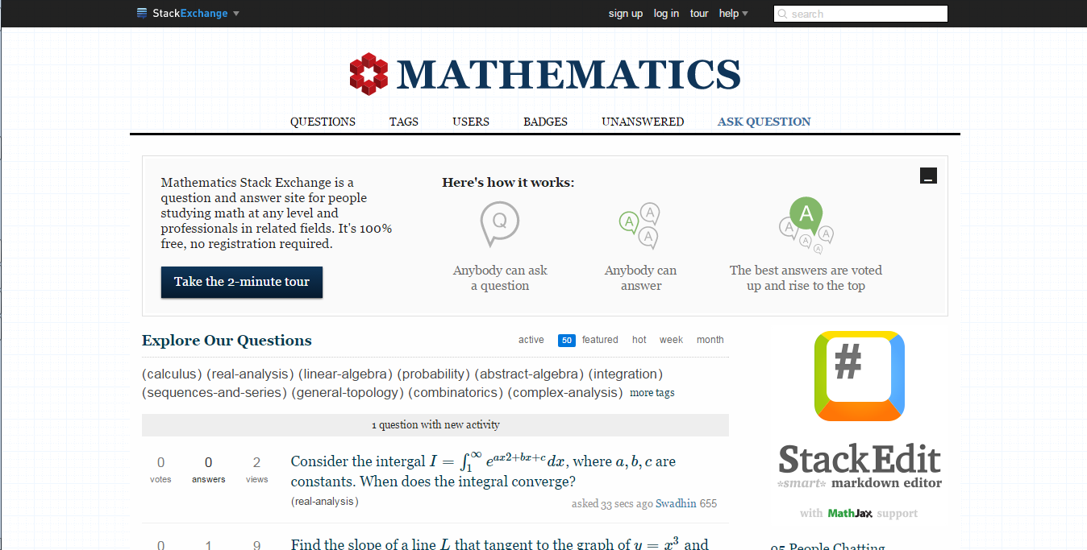

1. ***Description:***

Mathematics Stack Exchange is a question and answer site for people studying math at any level and professionals in related fields. It's built and run by you as part of the Stack Exchange network of Q&A sites. With user in the world, they build a library of detailed answers to every question about math.

1. ***Advantages and disadvantages:***

* *Advantages:*
* Good answers are voted up and rise to the top.
* The person who asked can mark one answer as "accepted".
* Tags make it easy to find interesting questions: each question can have 5 tags.
* You earn reputation when people vote on your posts.
* Improve posts by editing or commenting:
  + - If you see questions or answers that can be improved, you can edit them.
    - Use comments to ask for more information or clarify a question or answer.
* Signing up with Facebook or Gmail…
* Share question via Facebook, Gmail.
* *Disadvantages:*
* Enter mathematical formula is difficult.
* Don’t support drawing.
* Don’t allow attach file or image.

1. **Code Project**
2. ***Info:***

* **Link:** <http://www.codeproject.com/>
* **Type:** community of Software development and Design developers
* **Topic:** programming, source code
* **Rank in Global:** 1 212
* **Total Sites Linking In:** 17 226
* **Belong to:** Code Project

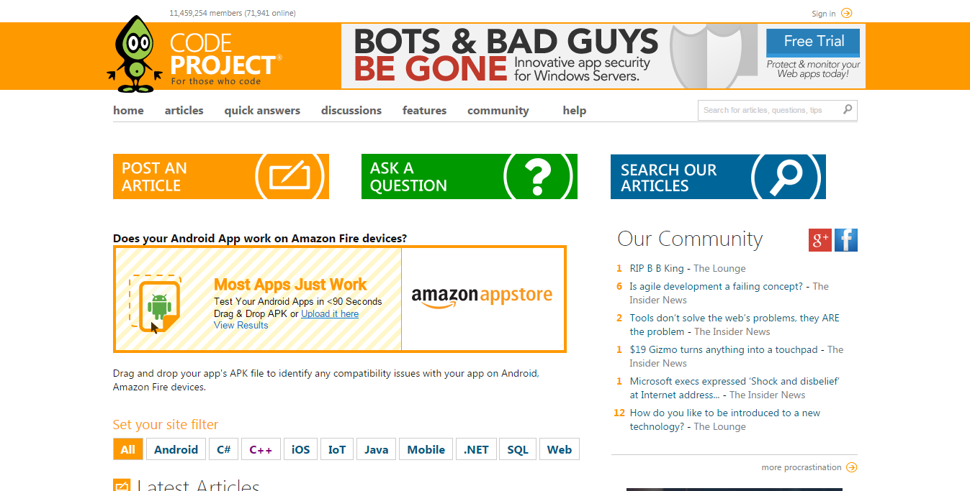

1. ***Description:***

CodeProject is a community of Software development and Design developers joined together with certain common goals: to learn, to teach and to have fun programming. Developers from all over the world come together to share source code, tutorials and knowledge for free to help their fellow programmers.

1. ***Advantages and disadvantages:***

* *Advantages:*
* Share source code, tutorials and knowledge for free to help their fellow programmers.
* Have discussion boards and support for code with the buttons.
* Post articles and vote on other authors' articles.
* The Lounge: to get together and ask advice to tell bad jokes and keep up with the latest industry gossip.
* Bookmark your favorite articles.
* Have your signature, name and contact details filled in automatically when posting to the discussion boards.
* Reserve your name. Once your name has been taken, one else can pose as you on the discussion boards.
* Have tag.
* Having system rating help improve reliability.
* Signing up with Facebook or Gmail…
* Share good articles with Facebook, Gmail, skype…
* *Disadvantages:*
* If user wants to view the comment, they must click each one.